Amitabh, Avishek Bachhan Test Positive for Covid-19
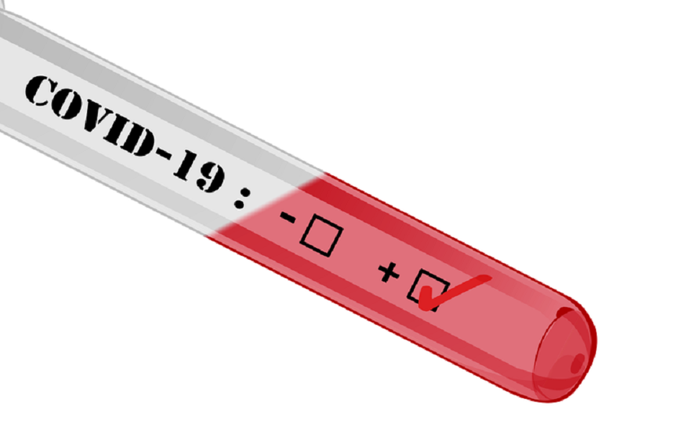

Bollywood superstar Amitabh Bachchan and his son Abhishek Bachchan on Saturday tested positive for coronavirus and have been shifted to a hospital.
In a Twitter post, Abhishek Bachchan said both have mild symptoms and their family and staff are being tested.
Earlier in the evening, Amitabh Bachchan also tweeted that he has tested positive and asked everyone who had come in contact with him in the last 10 days to get tested as well.
Both of them have been admitted to Nanavati Hospital in Mumbai
People across the country have tweeted their wishes for their quick recovery.
Amitabh Bachchan was roped in by the government in March to help spread awareness about the pandemic. He was recently seen in Shoojit Sircar's Gulabo Sitabo, co-starring Ayushmann Khurrana, which was released digitally on Amazon Prime Video. He is also scheduled to host the season 12 of the popular quiz show, Kaun Banega Crorepati.
Abhishek’s latest release is Amazon Prime’s Breathe: Into The Shadows.

